SIMATS ENGINEERING
ASSESSMENT TOOL 2

COURSE NAME: Database Management Systems
COURSE CODE: CSA05

COURSE OUTCOME COVERED

CO1: Analyse DBMS architecture, different data models, schema types, and design ER/EER diagrams, relational schemas for case-based scenarios by identifying entities and relationships. (BL1, BL2)

Activity Tool : Concept Mapping (Medium)
Assessment Tool Weightage: 20%

QUESTIONS
Q.N o | Question | Bloom's Level
1 | Construct a concept map linking the following terms: DBMS, Schema, Instance, Data Model, ER Diagram, Entity, Attribute, Relationship. | BL2 – Understand
2 | Create a concept map for the three-level ANSI/SPARC architecture showing data independence at each level. | BL2 – Understand
3 | Map the relationship between file-based systems and database systems, highlighting the problems solved by DBMS. | BL2 – Understand
4 | Design a concept map for ER diagram components: entity, weak entity, attribute types, relationship types, and participation constraints. | BL2 – Understand
5 | Construct a concept map comparing Hierarchical, Network, and Relational data models with their key properties. | BL2 – Understand
6 | Develop a concept map for the EER model showing how it extends the basic ER model with generalization, specialization, and aggregation. | BL2 – Understand
7 | Create a visual concept map for the DBMS software architecture, illustrating the flow from user request to data retrieval. | BL2 – Understand
8 | Map the data models discussed in CO1 to real-world applications and explain the suitability of each model. | BL2 – Understand
9 | Construct a concept map for schemas and instances, showing how they relate to physical and logical data independence. | BL2 – Understand
10 | Design a concept map for the roles and responsibilities in a DBMS environment: DBA, End User, Application Developer. | BL1 – Remember

Code of Conduct:
Criteria | Weightage | Level 4 (Exemplary) | Level 3 (Proficient) | Level 2  (Developing  ) | Level 1 (Beginning)
Concept  Identification | 25% | Identifies all key concepts from literature  accurately and  comprehensivel  y | Identifies most key concepts  with minor omissions | Identifies limited  concepts; some are  irrelevant or missing | Fails to identify  essential concepts
Linkages | 25% | Establishes clear,  meaningful, and accurate  relationships between concepts | Shows correct  relationships  with minor gaps | Relationship  s are weak,  unclear, or partially incorrect | No meaningful relationships established
Organization | 20% | Concepts are well-structured hierarchically  with logical flow and grouping | Mostly organized  with minor  structural issues | Some  organization but lacks clear hierarchy | No logical organization or structure

I Gunavathi. A (192511374) (Name / Reg No) certify that this submission is my original work and that I have adhered to the guidelines specified for this assessment. I understand that any violation of academic integrity rules will result in disciplinary action.

- Gunavathi
Signature of the student:

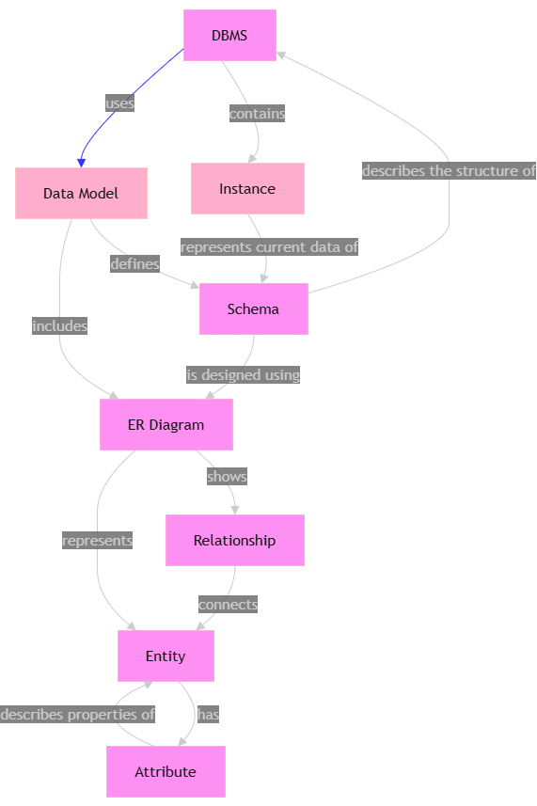
- Construct a concept map linking the following terms: DBMS,Schema, Instance, Data Model, ER Diagram, Entity, Attribute,Relationship.

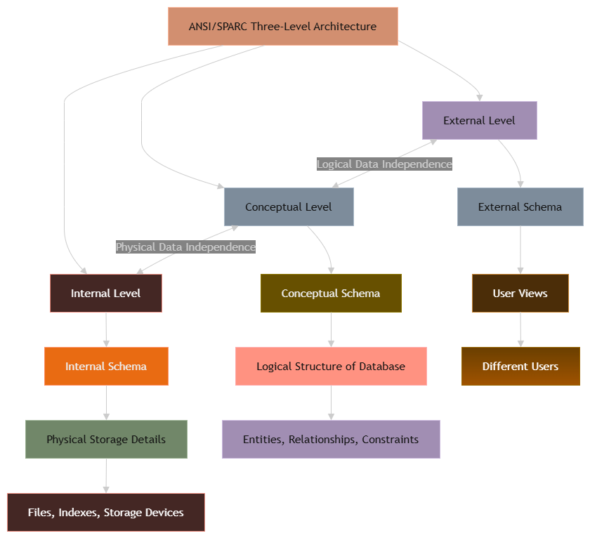
2)Create a concept map for the three-level ANSI/SPARC architecture
showing data independence at each level.

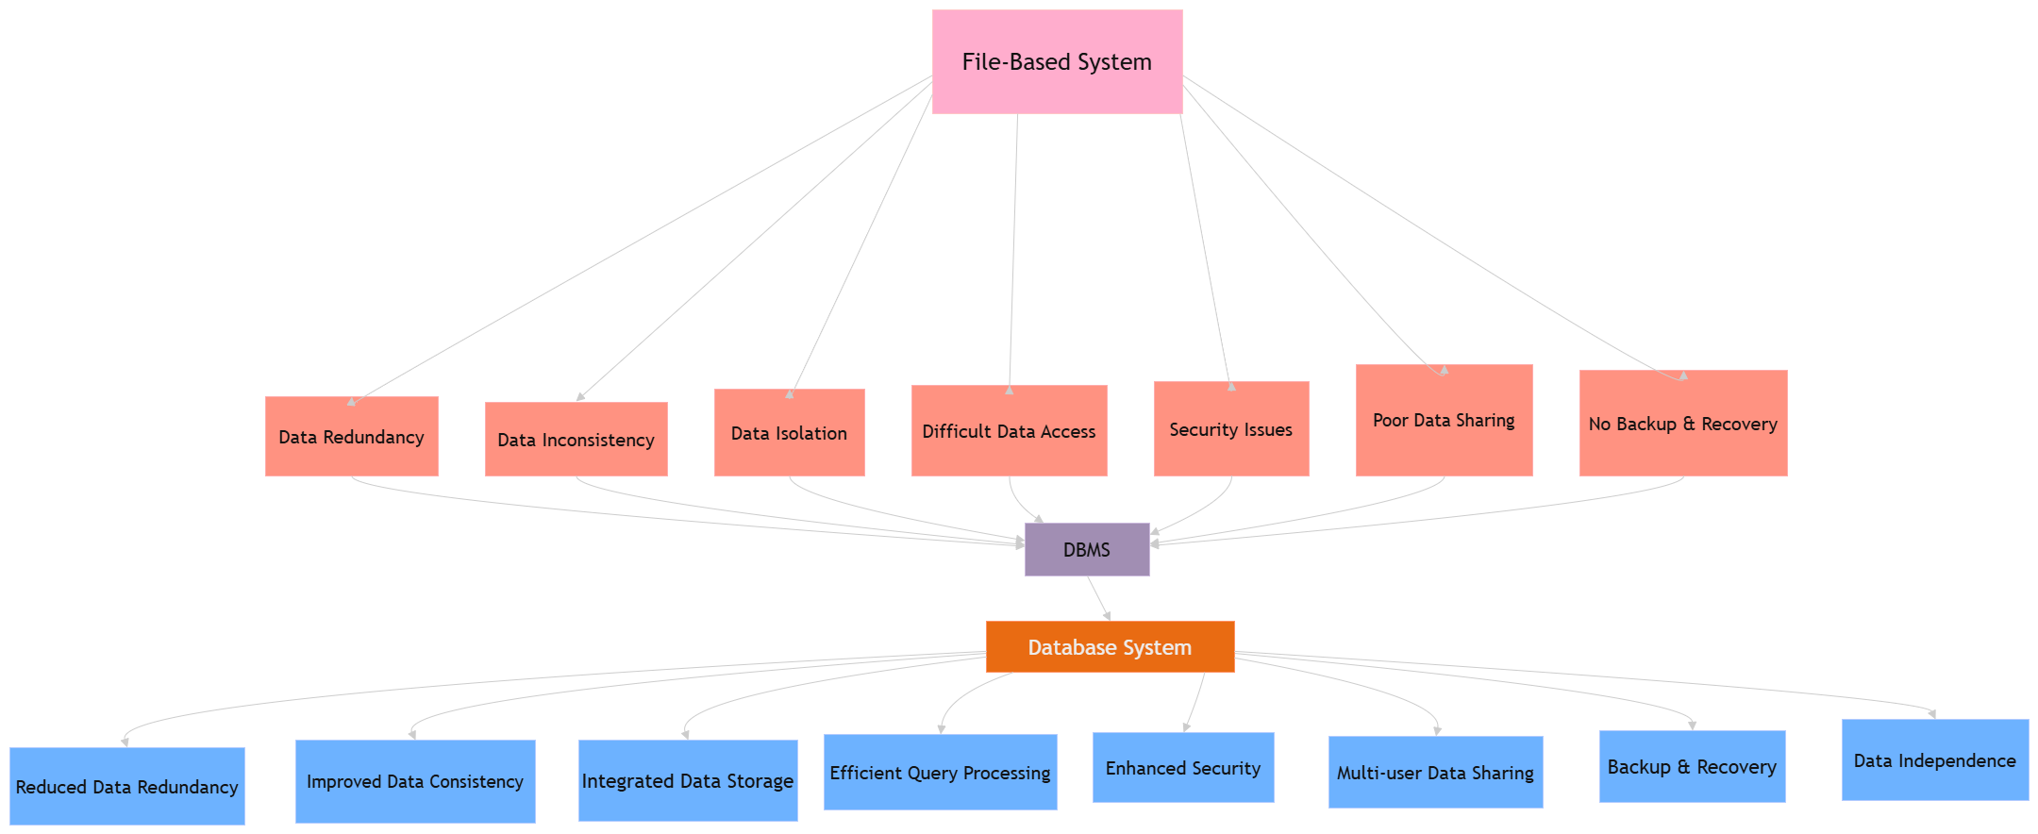
3) Map the relationship between file-based systems and databasesystems, highlighting the problems solved by DBMS.

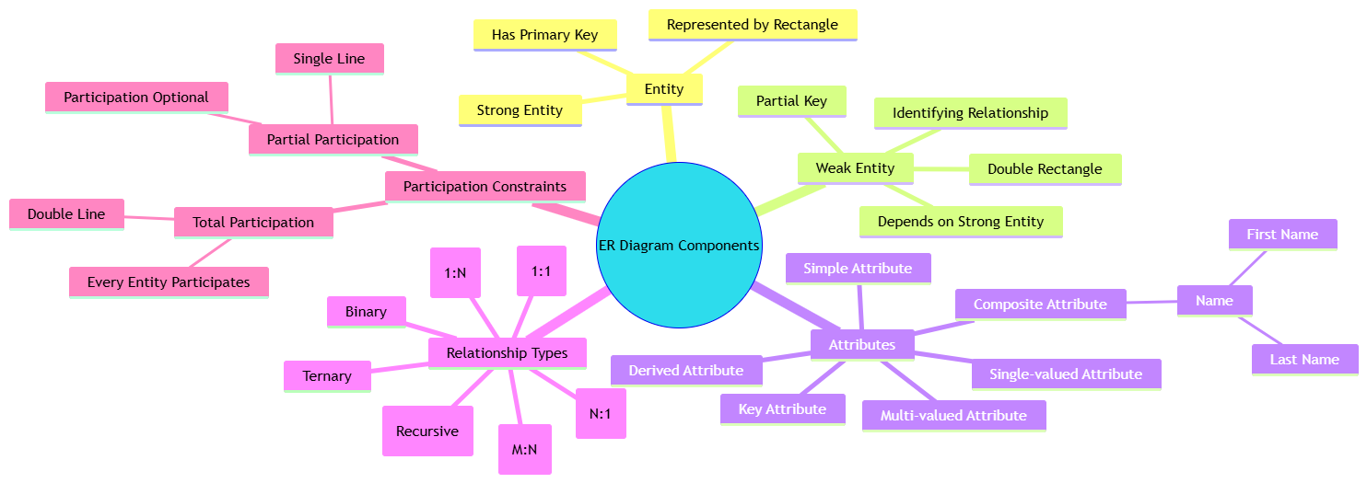
4) Design a concept map for ER diagram components: entity, weakentity, attribute types, relationship types, and participationconstraints.

5) Construct a concept map comparing Hierarchical, Network, andRelational data models with their key properties.
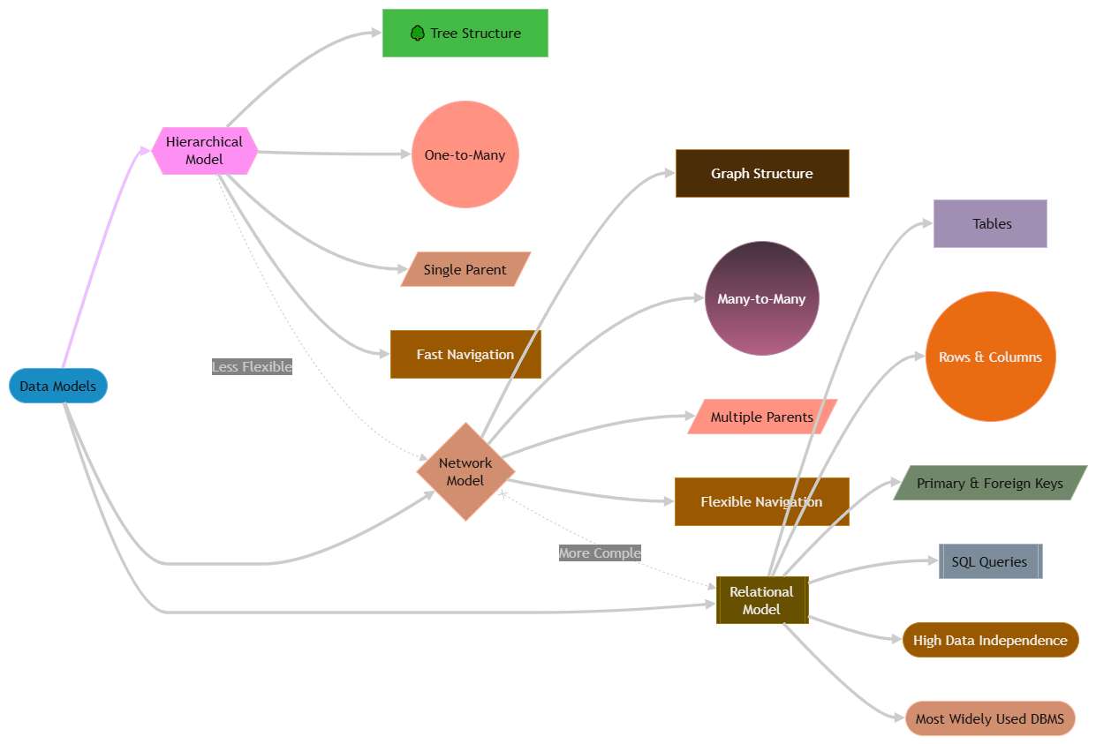

6) Develop a concept map for the EER model showing how it extends the basic ER model with generalization, specialization, and aggregation.
aggregation.

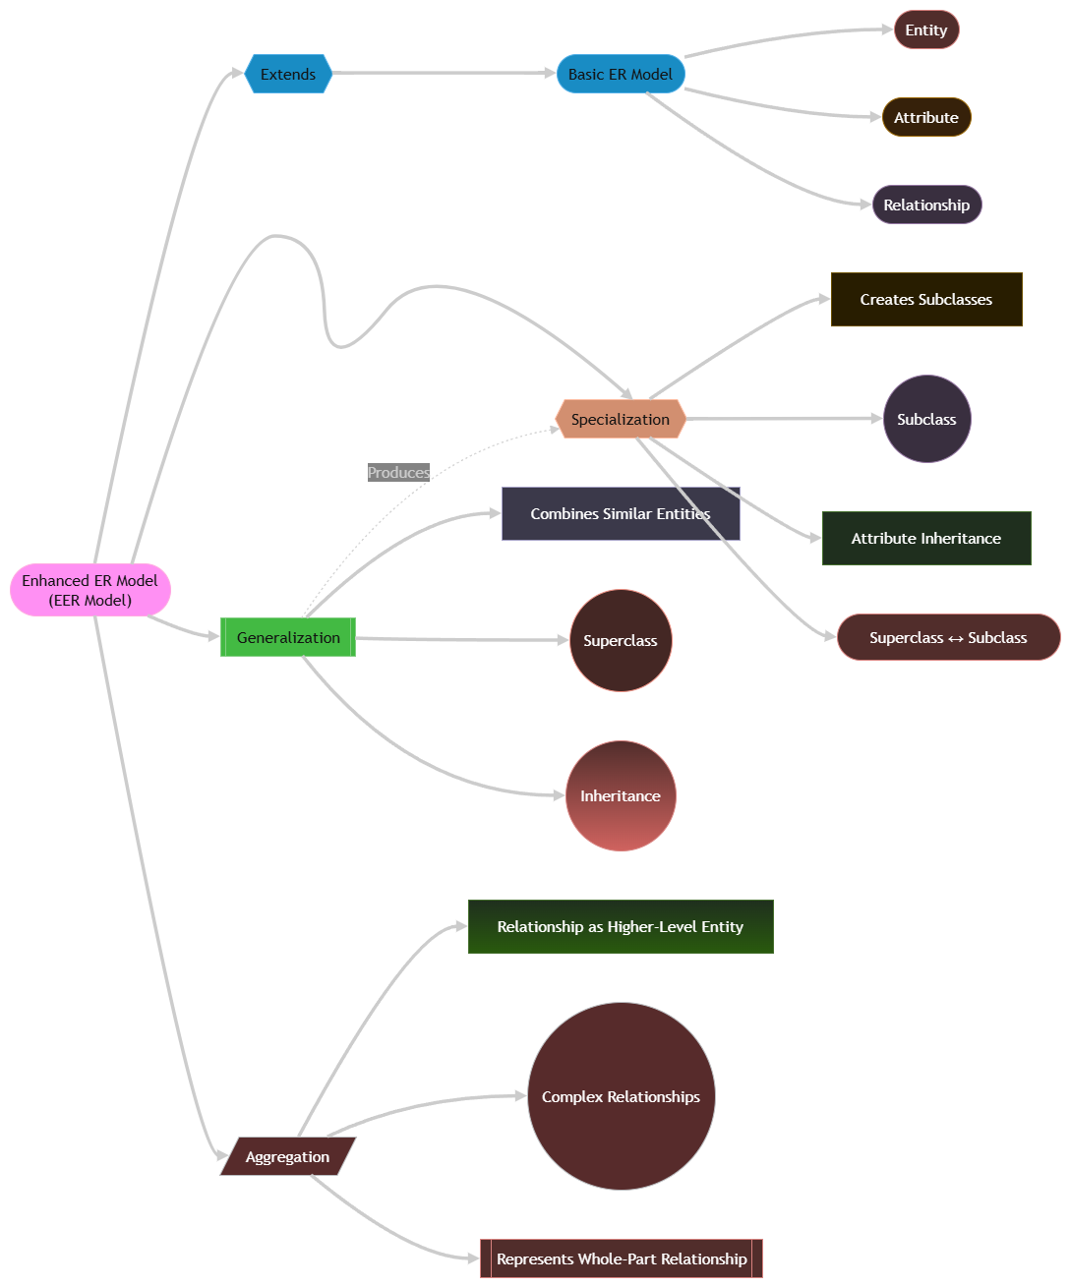

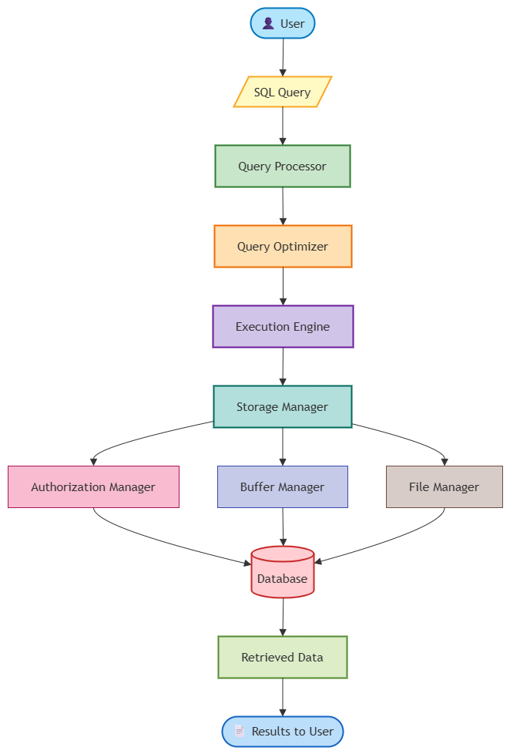
7) Create a visual concept map for the DBMS software architecture, illustrating the flow from user request to data retrieval.
illustrating the flow from user request to data retrieval.

8)Map the data models discussed in CO1 to real-world applicationsand explain the suitability of each model.

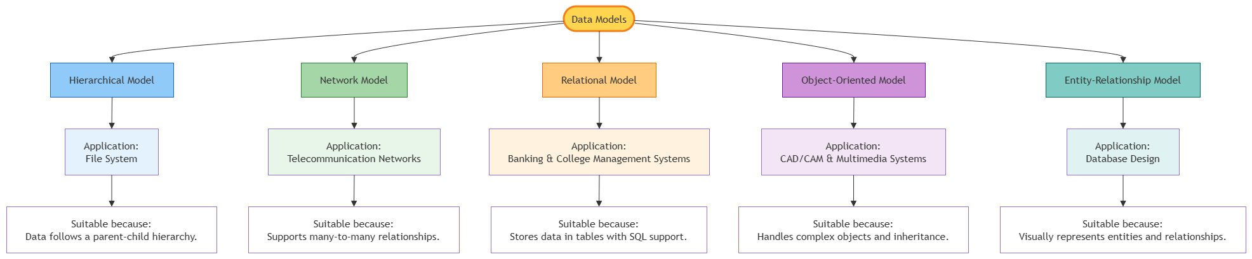

9) Construct a concept map for schemas and instances, showing how they relate to physical and logical data independence.

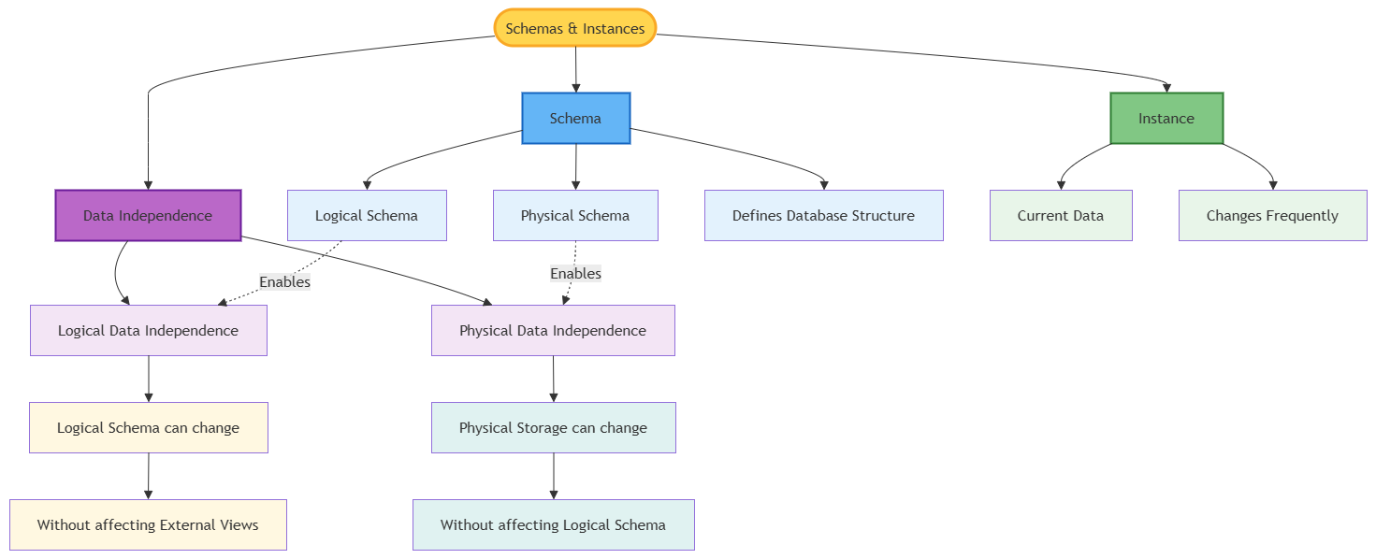

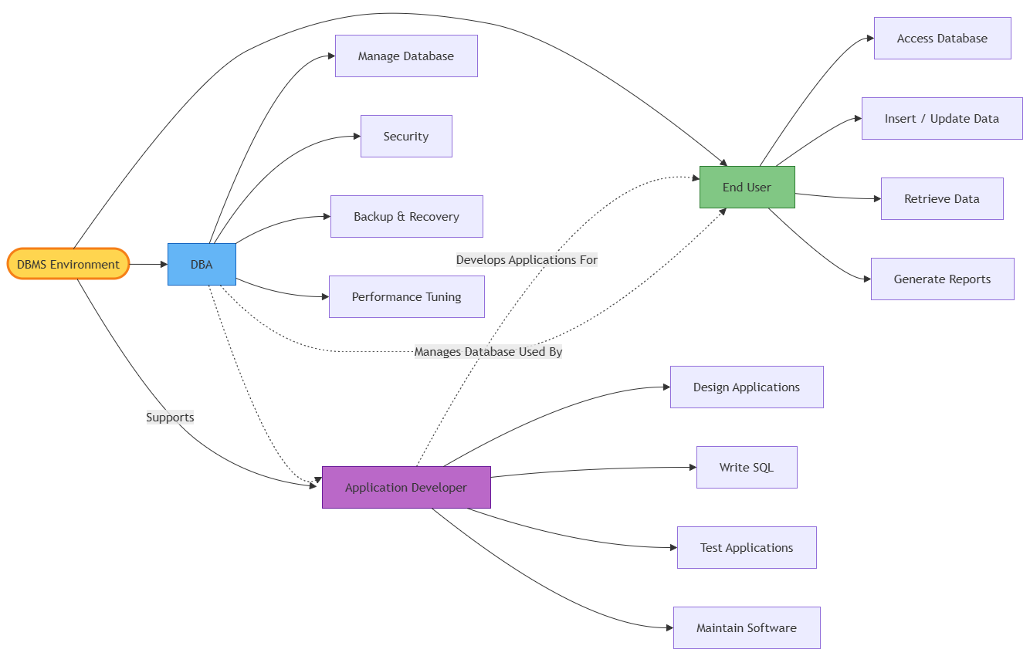
10)Design a concept map for the roles and responsibilities in a DBMS : DBA, End User, Application Developer.
environment: DBA, End User, Application Developer.

RUBRICS FOR CALCULATION:

Integration of Literature | 20% | Integrates multiple studies effectively to show  connections and comparisons | Shows some integration of literature | Limited integration; mostly  isolated concepts | No integration of literature evidence
Clarity | 10% | Concept map is clear, neat, visually  structured, and easy to interpret | Generally clear with minor  readability issues | Clarity is reduced;  difficult to  interpret in parts | Poorly presented and hard to understand

